**Software Development Lifecycle (SDLC) at Etsy: A Practical Approach**

**Etsy’s**

**Getting to Know Etsy's Development Process**

AComparative Study of Different Models in Relation to Etsy’s Software Development

**Ayush B Shetty**

**Nitte Mahalinga Adyantaya Memorial Institute of Technology**

[**nnm23is029@nmamit.in**](mailto:nnm23is029@nmamit.in)

<https://github.com/ayushshetty13/sdlc_etsy/edit/main/README.md>

**Keywords: SDLC, Etsy’s, AWS, Integration, Testing, Scalability, Requirements validation**

**The abstract**

As the Design and environment for the online marketplace has no means of absolute chance for completion unless systematic and coherent approaches in the software development area are made. It discusses the various SDLC models that have helped Etsy upgrade the working of the website, secured payment methods, and technology-enabled upgrades. We discuss the incremental, Spiral, and Waterfall approaches that Etsy has employed to maintain proper competition against rival products in e-commerce.

This is a comprehensive lecture on how Etsy is creating its own platform through continual improvements, iterations, and new features that are continually being introduced and that meet the requirements laid down by industry benchmarks and competing standards in the online marketplace.

**Table of Contents**

**1.Introduction………………………………………………………………………………………………3**

**2.SDLC Models and Their Role in Etsy’s Growth……………………………………3-11**

**2.1 Incremental Development Model**

**2.2 Spiral Model**

**2.3 Waterfall Model**

**3.How Etsy Handles Software Requirements…………………………………………11-12**

**3.1 Functional Requirements**

**3.2 Non-functional Requirements**

**3.3 How Etsy Validates Its Requirements**

**4.Challenges in Software Development at Etsy………………………………………12**

**5.Future Trends in Etsy’s SDLC Approach……………………………………………….12**

**6.Conclusion………………………………………………………………………………………….12**

**7.References………………………………………………………………………………………….13**

**1. Introduction**

Software development is not mere coding; it has grown an increasingly creative art in constructing marketplaces characterized by the coexistence of security, safety, scalability, and interactivity to achieve business objectives. With an assumption of integration on a single interface of millions of independent sellers and buyers, the IIWES had to morph into a structured approach for a format under software development.

Etsy engaged in a routine development cycle paired with new feature and enhanced security updates. The SDLC is of shortterm guidelines, usually maintaining a fairly stable approach. This report focuses on the SDLC methodologies instigated by Etsy and what contributes to their success.

Etsy's SDLC methodology smoothens upgrades while ensuring compliance with global practices, thus bringing to life a streamlined shopping experience for buyers as well as sellers.

**2. SDLC Model and Their Contributions for the Growth of Etsy.**

**2.1 Model of Incremental Development**

Development learns gradual and timely from the feedback for the evolution and several phases of Etsy. Incremental models work on small modules until the build is complete. As such for an e-commerce platform like Etsy, many phases would be likely, with periodic feedback and improvements to ensure

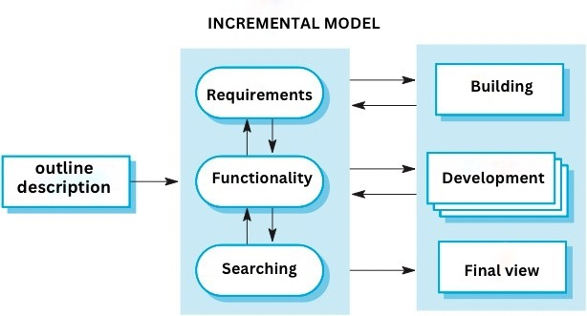

**1. Initial Planning and Requirements Gathering**

Identifying the core vision of establishing Etsy as a marketplace for handmade, vintage items, and craft supplies through understanding the basic needs of both buyers and sellers. In its preliminary period (2005), Etsy had the purpose of being the platform that connected buyers with sellers who worked by hand. Above all, the original aim was to create an online space where artisans could sell their work and buyers could seek out unique handcrafted items. The supporting requirements were very simple-a user-friendly interface which should have allowed sellers to list their products and buyers to search and choose the desired.

**2. CoreE-Commerce Functionality**

Creating the platform with core marketplace features. Initial planning towards its launch in 2005 saw Etsy come into the live environment with the different basic yet crucial e-commerce functionalities of user registration for buyers and sellers, product listings, and a rudimentary checkout. The seller was allowed to upload products with images, descriptions, and prices.

**3. Better Searching, Navigation, and Seller Tools**

Upgrading the platform to have better search and filtering systems to help sellers manage their stocks and orders. Products are filterable by many criteria, including price range, seller location, and product type. A primitive product management tool became available for sellers to manage their listings, sales activity, and buyer interaction. Product recommendations based on buyer behavior started surfacing on Etsy. The site would gain greater appeal and usability and provide sellers with much more power.The process may get delivered with more functionalities.

**Social Features and Trust-Building Tools:**

Love these features because they encourage social from the user end, helping to build trust through reviews and community engagement. Customer reviews, favorites, and options for social sharing were embedded in the application itself. The buyers could leave ratings, some comments on products and sellers, thereby integrating social media with this item and shop exposure. The combinations of more social engagement added buyer trust into making Etsy become the community of buyers and sellers.

**Mobile Optimization and App Development:**

As mobile usages continue to increase, developing mobile apps will give it a foothold for better mobile interaction. By 2010, it was totally clear to Etsy that mobile application usage had grown well, and so there would be a function for simple adaptability to mobile function, such as its own mobile optimised site, besides native apps.

**Functionality:**

The site continues to change its searching algorithm for sellers to be able to easily discover products on Etsy. New seller tools or features are slowly being rolled out, like automatic pricing suggestions for unique items.The phased rollout allows other processing improvements to be rolled out gradually to minimize disruptions.

**Non-Functionality:**

Architectural defects may occur at that time upon multiple feature releases continuously. Older features may simultaneously get obsolete with the ever-growing increase of the platform demands.

**Management of Risk and Change:**

In this manner, the risk is killed simply because Etsy can be made to go back and look to effect a change with feedback arrived at before every full feature is introduced. It also gives the company a chance to respond very fast to market trends because of the rollout which has been phased in.

**The Etsy Case in Review:**

Starting from A base product recommendation system that runs on an AI, Etsy would bring into play machine-learning development that personalizes recommendations based on user actions.Addition of the iterative model would allow many different features to be worked on in a parallel fashion by different people. teams, creating rapid development.

**2.2The Spiral Model**This is a hybrid iterative-based model that emphasizes risk management. This model highly suits larger projects with continuously changing requirements. The spiral model is an iterative risk-driven software development model that combines features of both the waterfall model and the incremental model.Spirals or cycles are repeated, one after the other. Each spiral comprises planning, risk analysis, development, testing, and review. This model is very suitable for complex, large-scale projects such as Etsy, whereby each iteration focuses on a separate goal, which minimizes risk while supporting system refinement.

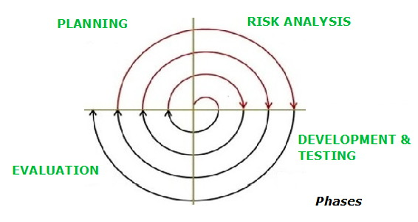  
  
**1. Planning and Requirements Gathering Own Needs and Scope of the Project.**Understanding goals, user requirements, and possible risks is imperative. The first cycle focuses on establishing the most basic requirements, planning and identifying risks. Issues requiring usability for both the buyer and seller were taken into account. Just identifying the needs of buyers and sellers. Initial Planning setting high-level goals for the platform. The main risk for this would be there is still no clear business model or customer base. A document stating high-level requirements.  
  
**2. Risk Analysis and Prototype Development:**Assess and solve-for the risks identified in the first phase-while developing a prototype demonstrating core functionality for the platform. A small team worked to develop a very crude version of the platform. The focus at this stage was to produce a working prototype that allowed users to list products, process simple transactions, and add capabilities as they matured. High-priority risks are addressed. A Minimum Viable Product (MVP) with early users is developed and made available for testing. Feedback from early adopters inspires further product improvements. Early-stage working version of the Etsy platform. Feedback from a small group of users highlighted issues with the design and user interface.

**3. Design and Development:**At this stage, it looked to improve upon a slightly more refined version of the system based on feedback by constantly evaluating the associated risks. They upgraded the previous prototype, but it remained just a basic marketplace. On top of the earlier feedback, Etsy now turned into refining the system. Options such as advanced product listing functionality. Robust search capabilities with categories and price ranges. A user interface a bit friendlier for both buyers and sellers. Technical risks such as the assurance of diverse payment options being in place and the security of user data. An e-commerce platform with the minimal features that exist live.  
  
**4. The testing, feedback, and refinement:**

The final step is the testing phase of bugs and collecting feedback, after which the platform applied is refined based on live use cases and other further risk analysis. System refinement enhancement of feedback output and fixing bugs and improving performance remained at the heart of this project phase. They identified the areas for improvement such as search, checkout flow, and the performance of the site. Risks involving user security, global performance issues, and scaling issues. Improved product search methods, an improved seller dashboard, a myriad of payment methods, and mobile site security. Moving up to a more stable scale was planned.  
  
**5. Final Release and Deployment:**

Deploying and broadcasting the final product establishes it to start stable production and check in for any remaining risks. The consolidated user base for Etsy becomes its major milestone towards growing seller availability. . Full-scale testing for stability and security for all major features before the launch. Continuous monitoring to ensure increasing traffic and transactions could not crash the platform. The primary risks at this point revolved around scaling and ensuring a rising number of users would not interrupt platform operations. Provided the reliability and stability of the platform.  
**6. Maintenance and Evolution:**  
Support and evolve the system through continuous feedback and improvement. Platform entered an ongoing improvement effort, introducing new features, expanding into other countries, and refining the system based on its user feedback. Regular updates for bug fixes, performance improvements, and implementing optimizations of features are provided. New analytics tools for the sellers, marketing features, mobile optimization, mobile apps for iOS and Android, and internationalization to support more languages and currencies. Monitor other risks, such as security conditions, platform downtimes, and competition, appearing repeatedly. Up-to-date surveillance for emerging risks and needs emanating from the customers.

**Functional Requirements-Purpose:**

• Well suitable for complex projects such as advancement in AI-based ad targeting for Etsy.

• Assists in evaluating buyer transaction take on risk.

• Continuous improvement and evolution due to live incidents.

**Non-Functional Requirements:**

• Very costly, re-testing, and risk considerations.

• A need for specialized skills in security, analytics, and development.

**Risk & Change Management:**

• Capture fraud and security threats before they run.

• Adaptable methodologies for allowing for changes after each iteration to improve fault tolerance on the systems.

Time and Cost Constraints:

• Very expensive, as there are repeated testing and developing cycles.

• Slower development but ultimately leads to a much safer and sturdier platform.

**Why Etsy Adopted This Framework:**

To discover and counteract security threats, ensuring compliance with regulations such as GDPR for the protection of personal information.

To enable for continuous feedback on the product before the launch of larger initiatives, such as dashboards for new seller analytics, fraud detection tools, etc.

**A practical example of Etsy:**

Etsy shall test the waters first to temporarily put a lid on some of the fraud gaps before deciding to set up stronger payment protection for the sellers.

**2.3 Waterfall Model**

The Waterfall model takes a linearly-structured approach and is very effective for fixed projects, which carry out little or no changes during development.The linear and sequential model of software development ensures that before shifting to the next step, each of the phases must be completed in their entirety.On the downside, although it is a bit flexible when compared to a few of the modern iterative approaches, it still would work smoothly on projects defined by clear expectations with minimum shifts during development.

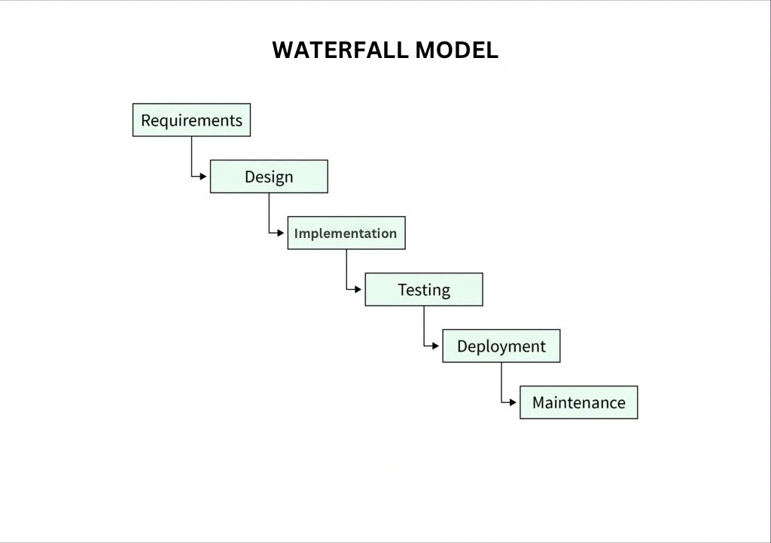

**1. Requirements Gathering and Analysis:**

- Collect and document the requirements for those projects for clear interpretation of what that platform delivers.A starting vision of an online marketplace focused on handmade, vintage, and craft supply items.A founding group further put the requirement as simple as possible for buyers as well as sellers:This allows sellers to list handmade and vintage products,Integration with payment systems, a secure shopping constraint for users, and tireless clarifications on projects and features that Etsy needed to develop for its first roll-out.

**2. System Design:**

- To create a high-level system architecture, database designs, and software component interactions based on the requirements in the second stage of project cycles.The objective is simple but strongly protective enough to realize the basic product listings searches and payment; the platform can permit the users to list their product offerings, search for them, and when they match search results, launch basic e-commerce functions.They were to design the database to store user profiles, product information, and transactions.A focus was put on simple UI to allow for easy navigation for buyers as well as sellers.Initial wire-frames or mock-ups of the site were to be shown to users.

**3. Implementation:**-The implementation should start according to the design specification. All the further developments should go on enhancing the eCommerce features to be well functioning and running in time for testing. User registration and profile management product listing function search and categorisation. . A basic manual website that gives functionalities such as user accounts, product listings, and a shopping cart.The implementation of the code that will provide the back-end of the Marketplace is ready for the first testing.  
**4. Testing:**The system should be tested against bugs, security issues, and usability problems, ensuring the correct working of the system for the design conditions of use and that it meets the requirements, as per the documentation. Testing that the user registration system was functional, listing of products, product searches, and accepting payments. User registration ability, listing products ability, searching the products ability, and payment capability will be tested. Assuring that the platform supports effective utilization for the benefit of both buyers and sellers. Ensuring security of payment details and processing the sensitive information appropriately. Reporting of the bugs, issues, or performance problems learned during the testing. Solving the problems encountered during the testing was done.  
**5. Deployment:**Work with the deployment to make the new system available to users within production systems. Probably this involves server setup, initial configuration, and launching of the website or system on public view. Testing to determine if the platform could handle traffic, ensuring examples weresecurely stored, and managing to perform well under heavy loads. Public knowledge of the online marketplace. Publicizing was mainly going to revolve around word-of-mouth and online marketing. The live one where users register, list products, and purchase items. Making sure that their actual website infrastructure could take care of the operations aspect.

**6. Maintenance:**

Daily management, maintenance, and updates of the system; provides operational support and enhancement of features throughout. Fixes bugs, acts on user requests, optimizes the site, and enhances the system with new features. Elimination of sporadic bugs or issues in real-time, features like item suggestions with a featured seller, mobile application development, and seller management enhancements had to be developed. Scalability to accommodate an increasing number of users and products was a requirement for the platform. Upgrading the platform with bug fixes and certain features. Ongoing customer support in problem and inquiry resolution.

**Functionality:**

• Good for structured processes, such as integration with third-party payment systems.

• Procedurally compact, appropriate libraries, and better services during the entire development process.

**Non Functionality:**

• Not suited for mutable projects.

• Later on, it would be excessively expensive when the changes are difficult to detect.

Risk and Change Management:

• A very high risk if the initial requirements are incorrect.

• Once the development has begun, making changes becomes extremely problematic.

Time and Cost Constraints:

• Lends itself to low-cost small and well-defined projects.

• Sequential execution would mean an additional stretch of time to accomplish the project.

**Etsy Example:**

Used for a back-end upgrade requiring a change management process to be followed. This would guide Etsy in keeping compliant with regulatory guidelines related to its payments policy updates. Software Requirement Specification for Etsy

**3.1 Functional Requirements**

• User authentication- Secure logins, multifactor authentication, and password reset.

• Product management- Simple seller tools for listing and managing products.

• Cart and checkout- Smooth and secure transactions with many options of payment.

• Order tracking and customer support-Easy order tracking and contact points with customer support for buyers.

**3.2 Non-Functional Requirements**

• Performance-Quick loading times under high shopping traffic.

• Security-There would be adequate protection against cards and fraud if user data is discovered and encrypted.

• Scalability-To accommodate additional buyers and sellers.

• Experience-Seemless and easy to navigate through all devices.

**3.3 Requirement Validation by Etsy**

Software development at Etsy proceeds along business directives and user and market demands-very extended testing before every software update sees the light of the day.Changes in place to proper management approaches to ease disruption.AI-driven monitoring systems act to discover and stop the spikes and run the performance of the system as a whole.

**4.Software Development Issues Faced by Etsy**

Scalability-The architecture must have room to grow: quickly, robustly, and that's in a manner that will take care of unforeseen growth.Cyber Security-Protection against fraud while protecting sensitive customer particulars.Regulatory Compliance-Whenever any changes to the international statutes or to taxes or laws are there and when operative.

**5.Future Trends in Etsy's SDLC Approach**

AI and Automation-Enhancing the speed of development by using AI coder editors and testing software.

Microservices Architecture-Where systems are broken down into small, decoupled, and refined, and maintainable services.

Blockchain-This will ensure the integrity of security and payment transparency.

**6. Conclusion**

For Etsy, software development means much more than just coding; it is a platform for buying and selling securely for millions of users across the globe.Etsy has been matching each turn of technological advance with stability-a need for them to assure their users a reliable platform, be it different SDLC models.Regardless of the software strategy, be it about personalizing the action of a newer portal or building another wall to make a fraud harder on the online shop, it's in its very character to guarantee upward competition.

**7. References**

Sommerville, Ian. Software Engineering (9th Edition).

Developer Documentation, Etsy.

Etsy official website - <https://www.etsy.com/>